**Projectile Motion**

**Pre-lab questions**

1. What is the goal of this experiment? What physics and general science concepts does this activity demonstrate?
2. In which direction does the acceleration due to gravity act?
3. If we ignore air resistance, is there any acceleration in the horizontal direction?

**Introduction**

The goal of the experiment is to investigate the projectile motion and to understand it as compound motion in two dimensions: vertical and horizontal. In this lab, you will solve a projectile motion problem and then check your theoretical result against the result of the corresponding experiment.

This lab will investigate projectile motion by studying vertical motion of objects that accelerate toward the Earth, then combining this information with knowledge of horizontal motion of objects near the surface of the Earth. Students will be able to synthesize this knowledge to describe combined horizontal and vertical motion of objects in two dimensions that are projected into the air.

The projectile motioncould be directed upward as a vertical projection, straight out as a horizontal projection, or at some angle between the vertical and the horizontal. A basis to understand such a compound motion is to understand that gravity is always acting on objects no matter where they are, and the acceleration due to gravity is independent of any motion that an object may have.

The relevant equations are those used for 1-dimensional motion with acceleration. The horizontal motion equations typically use the letter “x”, and they do not include an acceleration in the horizontal direction when force of air resistance is ignored:

$$\begin{aligned}x_{f}=x_{i}+v_{xi}t+\frac{1}{2}a_{x}t^{2}\#\left(1\right)\end{aligned}$$

$$\begin{aligned}v_{xf}=v_{xi}+\frac{1}{2}a_{x}\#\left(2\right)\end{aligned}$$

The horizontal range ($x_{f}-x_{i}$) of the projectile is the horizontal distance travelled.

The initial horizontal velocity is unchanging if we ignore air resistance ($v_{xf}=v_{xi}$).

The vertical motion equations typically us the letter “y”. Here it is important to define a positive and negative direction, usually “up” is positive and “down” (toward the center of the Earth) is negative:

$$\begin{aligned}y_{f}=y_{i}+v_{yi}t+\frac{1}{2}a_{y}t^{2}=y_{i}+v_{yi}t-\frac{1}{2}gt^{2}\#\left(3\right)\end{aligned}$$

$$\begin{aligned}v_{yf}=v_{yi}+\frac{1}{2}a_{y}t=v_{yi}-\frac{1}{2}gt\#\left(4\right)\end{aligned}$$

where  **m/s2**. These two sets of equations are connected by the time in flight (*t*).

If you launch a ball horizontally from the edge of a table with initial velocity $v_{0}=v_{xi}$, it becomes a projectile. The motion of such a projectile is easier to understand if you split the complete motion into vertical and horizontal components using the equations above. After the ball leaves the table, there is a gravitational force that accelerates the ball vertically downward. The ball thus has an increasing downward velocity the same as that of dropped ball because the initial *y* component of velocity was zero.

The vertical component of the velocity $v_{y}$ is represented by the vertical arrow in Fig. 1. Gravity plays no role in the horizontal direction, so acceleration in that direction of motion will be zero. Ignoring air resistance, there are no forces in the horizontal direction so the horizontal component of velocity $v_{x}$ remains constant and is equal to the initial horizontal velocity ${ v}_{X }={ v}_{0}$, as shown by the horizontal vector arrows in the Figure 1 below.

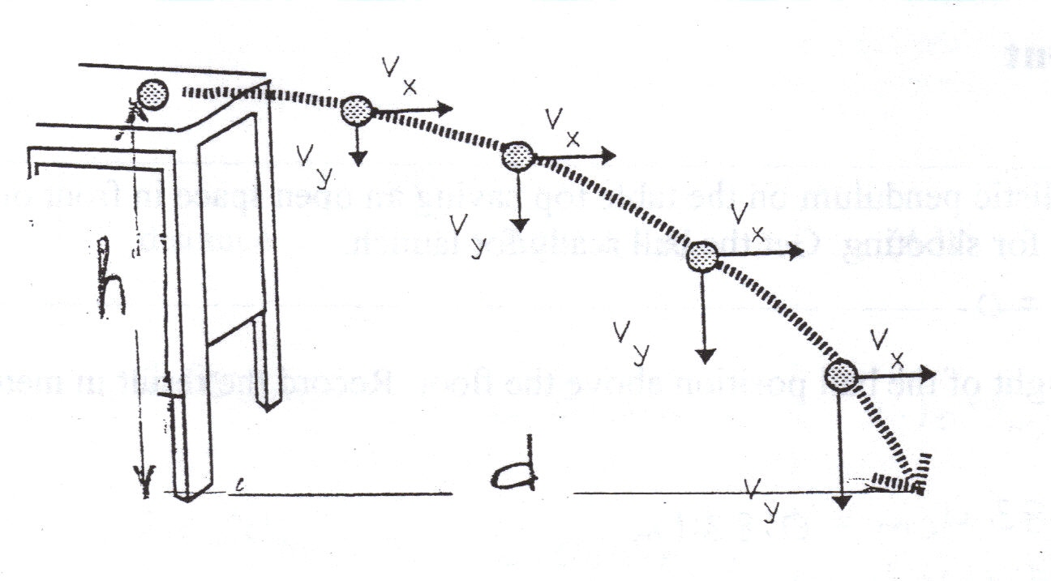

The verticaldistance that a falling ball moves is the **height $h=y_{i}-y_{f}$** . When we substitute this information into our kinematics equations along with the information that $v_{yi}=0$ for this case, we see that the height is proportional to the square of the time that the projectile is falling vertically:

$\begin{aligned}h = ½ g t^{2}\#\end{aligned}(5)$

where acceleration due to the force of gravity near the surface of the Earth is:

**g = 9.81 m/s2**

The horizontalrange that the ball moves is the **distance** (or range) $d=x_{f}-x_{i}$. It depends on the ball’s horizontal velocity $v_{x}$. In this case, that is the initial velocity of projectile $v_{0}$.

$\begin{aligned}d = v_{0}*t\#\left(6\right)\end{aligned}$

Time ties these two dimensions (vertical height and horizontal range) together: the time it takes the ball to fall to the ground is also the time it will travel horizontally.

Measuring the height **h** and the range **d** you could find initial velocity **V0** experimentally:

$\begin{aligned}V_{0}=d/t\#\left(7\right)\end{aligned}$

where time can be found from the vertical motion equation: $\begin{aligned} t =\sqrt{\frac{2h}{g}}\#\left(8\right)\end{aligned}$

In this lab experiment you will use a projectile launcher as the device to launch a plastic ball. You will determine experimentally the initial velocity *v0* of the projectile by launching the projectile vertically – these equations of motion will be slightly different than those above.

The ball is launched by a compressed spring. To get the ball ready for launch push the ball against the spring until it latches. To launch the ball, you just need to push on the release handle.

**Equipment**

* table clamp
* projectile launcher
* meterstick
* rod
* carbon paper
* target paper

## Experiment

## Step 1: Determine v0 of the projectile launcher

Determine vo by launching the ball vertically 10 times. Measure the maximum height Hi of the trajectory each time using a 2m stick.

* To launch the ball vertically, position the projectile launcher vertically on the floor.
* It is crucial that the launcher is pointed straight up, since the uncertainty in H will determine the final allowed uncertainty for the predicted range of the projectile.
  + Thus be careful about avoiding systematic errors in the reading of H: For instance avoid parallax error by making sure that your eyes are roughly at the same height as your reading on the meter stick.
  + Also be careful to measure the height of the trajectory from the point where the ball is launched to the point where the ball actually starts to be in “free fall” (i.e. when gravity becomes the only force acting on the ball).
* Enter your height measurements in Table 1 (include units!), and determine for each the corresponding value of the initial velocity using the appropriate formula:

$$v_{0}=\sqrt{2gH}$$

Use equations 1 through 4 to show the derivation of this formula in the space below:

Table 1. Vertical projection

|  |  |  |  |
| --- | --- | --- | --- |
| Maximum height H | Initial velocity v0 | Deviation | Squares of deviation $${\left[∆v\right]}^{2}$$ |
| Units: | Units: | Units: | Units: |
|  |  |  |  |
|  |  |  |  |
|  |  |  |  |
|  |  |  |  |
|  |  |  |  |
|  |  |  |  |
|  |  |  |  |
|  |  |  |  |
|  |  |  |  |
|  |  |  |  |

Average initial velocity: _______________

Standard deviation of mean (where *n* is the number of trials:

$σ_{m}=\sqrt{\frac{\sum{{\left(∆v\right)}^{2}}}{\left(n-1\right)n}}$

Report your result as an average value plus or minus a deviation (write both numbers separately; do not complete the addition/subtraction)

$v=v_{av}±σ_{m}$ (with units!):

**Step2: Range prediction for horizontal projection**

The projectile will now be launched horizontally from a tabletop. Before launching, you must predict where on the floor your projectile will land. We will do this systematically using our physics equations, not by trial and error.

* Place your launcher on the table and adjust it to be pointed horizontally. Use the attached protractor to confirm this. Measure the initial launch height of the ball above floor level (with units!).

***h =***

* Derive a formula for the predicted range of the ball from the equations of uniformly accelerated motion in two dimensions (1-4). Show your algebra below:

Givens:

Vertical equations:

Horizontal equations:

$x_{f}=$ units:

* Using your initial velocity determined in step 1 (now pointed horizontally!) and the measurement of the ball’s initial height above the floor, calculate the predicted range of the ball for $v_{av}$, for $v_{av}+σ_{m}$, and for $v_{av}-σ_{m}$. Don’t forget units.

Predicted range (from $v_{av})$:

Maximum range (from $v_{av}+σ_{m}$):

Minimum range (from $v_{av}-σ_{m}$):

**Step 3: Test Your Prediction**

* Draw a line horizontally across a piece of paper (this is your target paper). You will align this with your predicted range. Draw two more lines that will align with your maximum and minimum range (from the previous step).
* Position the ballistic pendulum on the table top.
* Tape your piece of paper on the floor at the location of the predicted range making sure that the three lines indicate predicted range, maximum predicted range, and minimum predicted range. **Do not launch the ball** **yet**.
* Call your professor over and have them check your set up.
* Place a piece of carbon paper over your lined paper.
* Launch the ball. The impact of the ball must fall in the interval on the paper for successful completion of the lab.

You may elect to verify your calculations for mistakes and correct them if necessary.

**Include conclusions and sources of error in your lab report.**